Database Transaction

🌟 Definition
# Source: AI Source: Provided by: [Data Path: Persons Table -> ID Column: 1, Name_En Column: Motasem Essam] -> From: [ChatGPT] on [6/10/2026]
A Database Transaction is a sequence of one or more database operations that are treated as a single unit of work.
Either:
- ✅ All operations succeed → transaction is committed.
- ❌ Any operation fails → transaction is rolled back.
This ensures that the database remains consistent and correct.

🎯 Purpose
# Source: AI Source: Provided by: [Data Path: Persons Table -> ID Column: 1, Name_En Column: Motasem Essam] -> From: [ChatGPT] on [6/10/2026]
- Maintain data integrity
- Prevent partial updates
- Ensure consistency
- Handle errors safely
- Support concurrent users

🧠 Simple Example
# Source: AI Source: Provided by: [Data Path: Persons Table -> ID Column: 1, Name_En Column: Motasem Essam] -> From: [ChatGPT] on [6/10/2026]
Imagine transferring $100 from Account A to Account B.
Steps
- Subtract $100 from Account A
- Add $100 to Account B
If step 1 succeeds but step 2 fails:
❌ Money disappears.
Using a transaction:
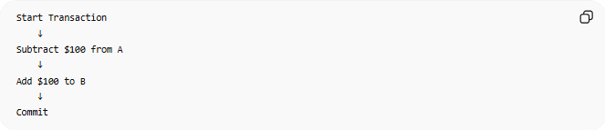
Start Transaction
↓
Subtract $100 from A
↓
Add $100 to B
↓
Commit
If any step fails:
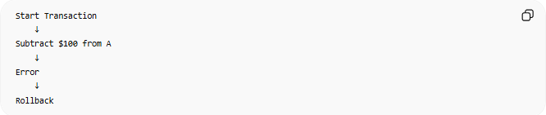
Start Transaction
↓
Subtract $100 from A
↓
Error
↓
Rollback
The database returns to its original state.

🔢 Main Transaction Operations

1. BEGIN TRANSACTION
# Source: AI Source: Provided by: [Data Path: Persons Table -> ID Column: 1, Name_En Column: Motasem Essam] -> From: [ChatGPT] on [6/10/2026]
Starts a transaction.
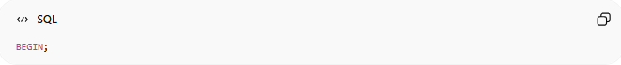
BEGIN;

2. COMMIT
# Source: AI Source: Provided by: [Data Path: Persons Table -> ID Column: 1, Name_En Column: Motasem Essam] -> From: [ChatGPT] on [6/10/2026]
Permanently saves all changes.
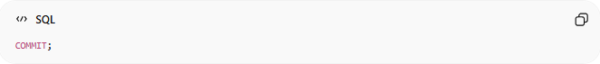
COMMIT;

3. ROLLBACK
# Source: AI Source: Provided by: [Data Path: Persons Table -> ID Column: 1, Name_En Column: Motasem Essam] -> From: [ChatGPT] on [6/10/2026]
Cancels all changes made during the transaction.
ROLLBACK;

📚 SQL Example

Without Transaction
# Source: AI Source: Provided by: [Data Path: Persons Table -> ID Column: 1, Name_En Column: Motasem Essam] -> From: [ChatGPT] on [6/10/2026]
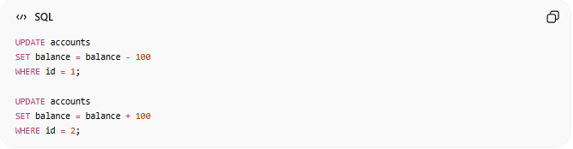
UPDATE accounts
SET balance = balance - 100
WHERE id = 1;
UPDATE accounts
SET balance = balance + 100
WHERE id = 2;
If the second query fails, data becomes incorrect.

With Transaction
# Source: AI Source: Provided by: [Data Path: Persons Table -> ID Column: 1, Name_En Column: Motasem Essam] -> From: [ChatGPT] on [6/10/2026]
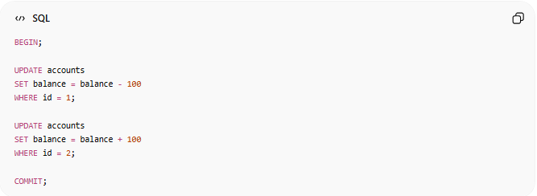
BEGIN;
UPDATE accounts
SET balance = balance - 100
WHERE id = 1;
UPDATE accounts
SET balance = balance + 100
WHERE id = 2;
COMMIT;
If an error occurs:
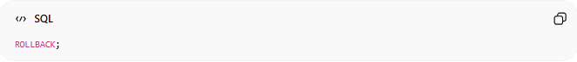
ROLLBACK;

🏦 Real-World Uses
# Source: AI Source: Provided by: [Data Path: Persons Table -> ID Column: 1, Name_En Column: Motasem Essam] -> From: [ChatGPT] on [6/10/2026]
Banking
- Money transfers
- Deposits
- Withdrawals
E-Commerce
- Create order
- Update inventory
- Process payment
Reservation Systems
- Airline bookings
- Hotel bookings
- Ticket sales
User Registration
- Create user
- Create profile
- Assign permissions

🔗 How a Transaction Works
# Source: AI Source: Provided by: [Data Path: Persons Table -> ID Column: 1, Name_En Column: Motasem Essam] -> From: [ChatGPT] on [6/10/2026]
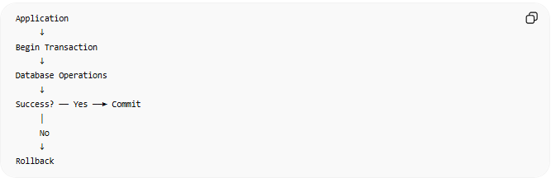
Application
↓
Begin Transaction
↓
Database Operations
↓
Success? ── Yes ──► Commit
│
No
↓
Rollback

🧠 Simple Analogy
# Source: AI Source: Provided by: [Data Path: Persons Table -> ID Column: 1, Name_En Column: Motasem Essam] -> From: [ChatGPT] on [6/10/2026]
Think of a transaction as:
📝 A contract
- Everyone signs → contract becomes official (COMMIT)
- Someone refuses → contract is canceled (ROLLBACK)
There is no half-completed contract.

🧭 Summary
# Source: AI Source: Provided by: [Data Path: Persons Table -> ID Column: 1, Name_En Column: Motasem Essam] -> From: [ChatGPT] on [6/10/2026]
A Database Transaction is a group of database operations executed as a single unit. It guarantees that either all changes are successfully applied (COMMIT) or none are applied (ROLLBACK), ensuring data integrity and consistency through the ACID principles.

